ANGLES IN PARALLEL LINES
Pearson Edexcel - Tuesday 19 May 2020 - Paper 1 (Non-Calculator) Foundation Tier

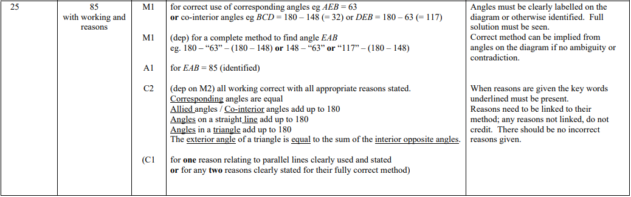

Pearson Edexcel - Thursday 8 November 2018 - Paper 2 (Calculator) Foundation Tier

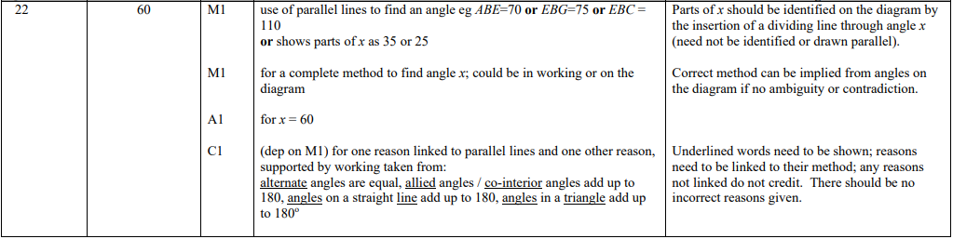

Pearson Edexcel - Thursday 2 November 2017 - Paper 1 (Non-Calculator) Foundation Tier

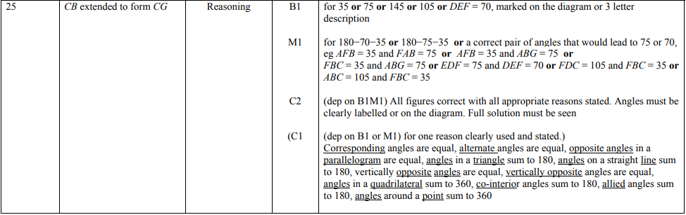

Pearson Edexcel – Specimen 2 - Paper 1 (Non-Calculator) Foundation Tier

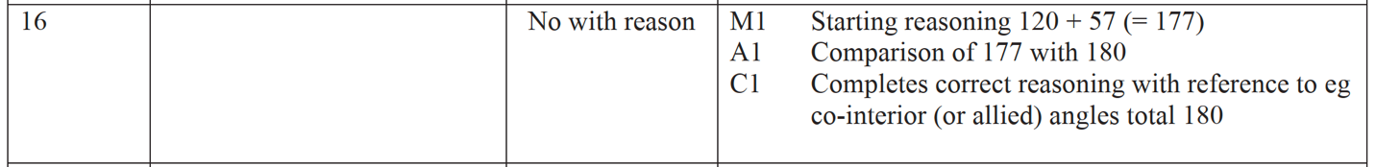

OCR Thursday 6 June 2019 – Morning (Non-Calculator) Foundation Tier

AQA Tuesday 13 June 2017 Morning– Morning (Calculator) Foundation Tier

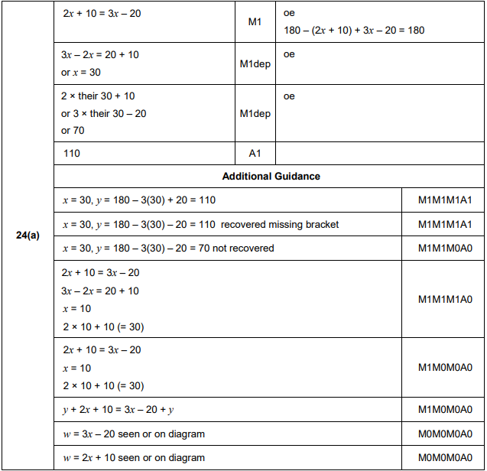
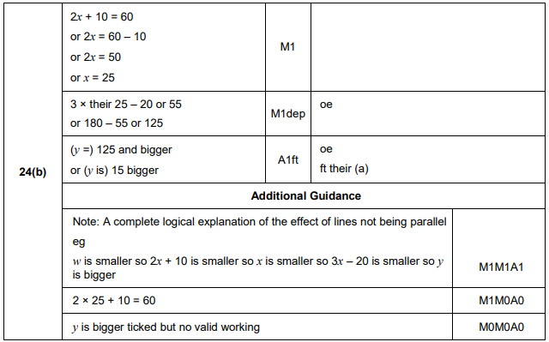

AQA Sample Paper 3– Morning (Calculator) Foundation Tier

